**Disease Management_USA & Heart Exploration**

TANVI GAWADE

CALIFORNIA STATE UNIVERSITY LOS ANGELES

SUBMITTED TO: DR. SHILPA BALAN

**TABLE OF CONTENTS**

**TOPIC pAGE NO**

**Dataset Topic** ------------------------------------------------------------------------------------------- **3**

**Introduction--------------------------------------------------------------------------------------------- 3**

**Objective------------------------------------------------------------------------------------------------- 4**

**Data Visualization--------------------------------------------------------------------------------------5**

**Report Designer--------------------------------------------------------------------------------------- 10**

**Story Telling--------------------------------------------------------------------------------------------11**

**References---------------------------------------------------------------------------------------------- 17**

**DATASET TOPIC**

**Disease_Management_USA**

[**Heart**](https://www.kaggle.com/danielgrijalvas/movies)

**INTRODUCTION:**

One in three Americans have high blood pressure, termed hypertension. Because such a large percentage of the United States population suffers from high blood pressure, it’s easy to get comfortable with the diagnosis. However, the commonality of this chronic condition doesn’t reflect its seriousness; when left untreated, it can lead to life-threatening health conditions.

Disease management is the concept of reducing health care costs and improving quality of life for individuals with such chronic conditions by preventing or minimizing the effects of the disease through integrated care. An integrated care approach to managing illness which includes screenings, check-ups, monitoring and coordinating treatment, and patient education. It can improve the quality of life while reducing health care costs for chronic disease by preventing or minimizing the effects of a disease. Disease management programs are designed to improve the health of persons with chronic conditions and reduce associated costs from avoidable complications by identifying and treating chronic conditions more quickly and more effectively, thus slowing the progression of those diseases.

Disease management is a system of coordinated heath care interventions and communications for defined patient populations with conditions where self-care efforts can be implemented. Disease management empowers individuals, working with other health care providers to manage their disease and prevent complications. Disease management has emerged as a promising strategy for improving care for those individuals with chronic conditions. People with chronic conditions usually use more health care services which often are not coordinated among providers, creating opportunities for overuse or underuse of medical care.

**OBJECTIVE OF THE STUDY:**

Generally, disease management program identifies the population group. Demographic characteristics, health care use and health care expenditures are generally reviewed to identify individuals who will benefit from a disease management program. Programs target individuals with a specific disease that is chronic in nature and costly. Providers within disease management programs are critical to educating patients about their disease and how to better manage their conditions. Practice guidelines based on clinical evidence ensure consistency in treatment across the targeted population. Chronic disorders commonly managed through disease management programs are:

* Asthma
* Heart disease (COPD)
* Breast cancer
* Type 1 Diabetes & Type 2 Diabetes

The main aim of a DMP is to reduce the symptoms associated with a chronic disease and keep them from getting worse. Other targets include trying to prevent complications or accompanying diseases from developing. In addition, this structured approach to treatment aims to help people cope with their disease and to show them ways of dealing with the demands of their treatment in everyday life. Disease management programs also aim to improve cooperation between the various specialists and institutions that provide care for a patient, such as family and specialist doctors, hospitals and rehabilitation centers.

Chronic diseases are complex conditions and require long-term regular treatment which should be tailored to suit the patient wherever possible. Insights derived Disease Management data would help manage diseases in the long term and improve the success of the treatment. It would also help the doctors to be well-informed about the course of the treatment and will be able to give more personalized attention during the regular appointments than they would be able to do in a normal consultation. All the therapists and carers involved, both in inpatient and outpatient treatment would be well coordinated their interventions with one another.

1. **DATA VISUALIZATION**
2. **State Rankings based on Systolic and Diastolic Blood Pressure Range**

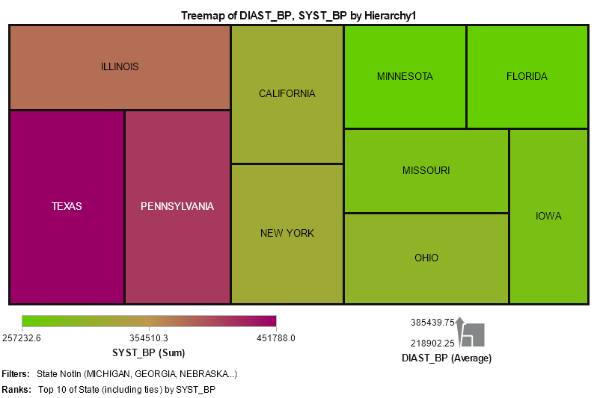

[Application Used: Treemap, Hierarchy, Filter, Rank]

Visualizations depicts the rankings of the countries based on the sum of systolic ranges of all the patients from the dataset which is demonstrated above in the form of a Treemap. The color intensifies with increase in the number of systolic blood pressure range for the patients whereas the size of every rectangle indicates the sum of diastolic range of all the patients. Higher the diastolic range from each state larger is the rectangle dimension. The visualization depicts that Texas has the highest range of patients with large range of systolic blood pressure as indicated by the intensity of color which is then followed by Pennsylvania, Illinois. The hierarchy would demonstrate which cities from each state have the patients with large number of systolic blood pressure range. We can observe that Texas, Pennsylvania and Illinois also have maximum patients with higher number of diastolic blood pressure which is shown with the help of the size of rectangle.

1. **Hypertension and Renal Disease by Age Rank 65-70**

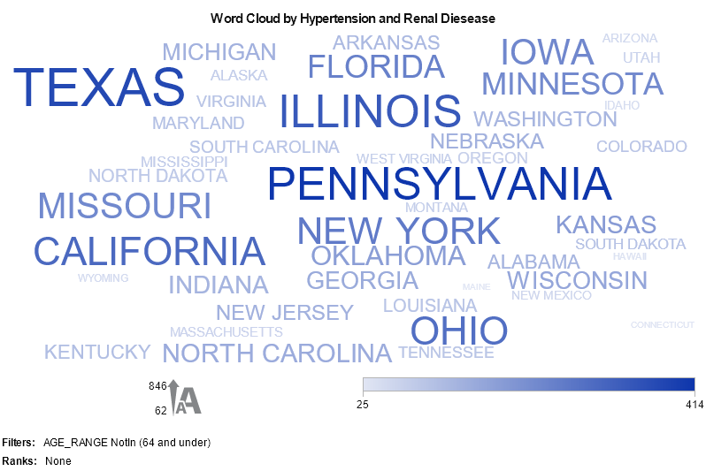

[Application Used: Word Cloud, Filter]

Visualization shows the states with the highest number of patients for Age rank 65 - 70 with chronic conditions Hypertension and Renal diseases. This has been demonstrated with the help of Word cloud where the sizes of the words show the large number hypertension patients in Texas, Pennsylvania and Illinois where as the intensity of the color shows us which states have a high number of patients with Renal diseases. Here we can observe that Pennsylvania followed by Texas have high number of patients with the condition.

1. **Interaction of Systolic and Diastolic Blood Pressure with Cholesterol Lipids**

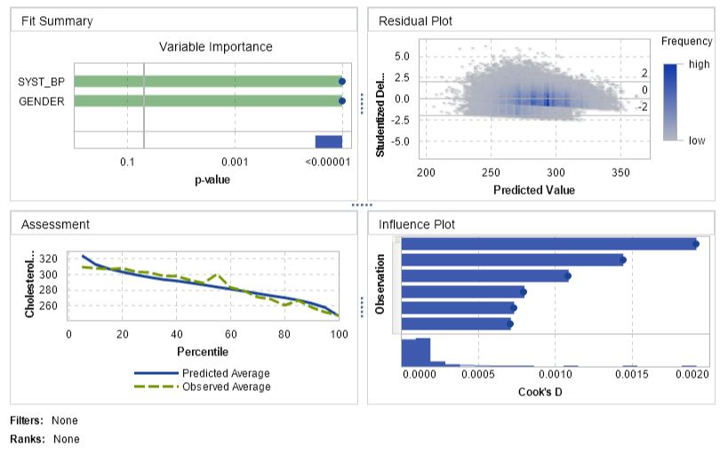

[Application Used: Linear Regression]

Visualization shows the impact of variables gender and the interaction variables systolic and diastolic blood pressure on the cholesterol range of the patient. The Assessment window indicates that the observed cholesterol and cholesterol average are approximately equal for most bins. Visualization demonstrates a strong relation between the variables systolic and diastolic blood pressures as well gender on the cholesterol range a patient would have. This would help anticipate for medical equipment’s to assess the cholesterol range with increase in blood pressure ranges for the patients and would indicate in advance for the precautionary steps to be taken to control the cholesterol range for a patient.

1. **Cholesterol by Blood Pressure Status and by Cause of Death**

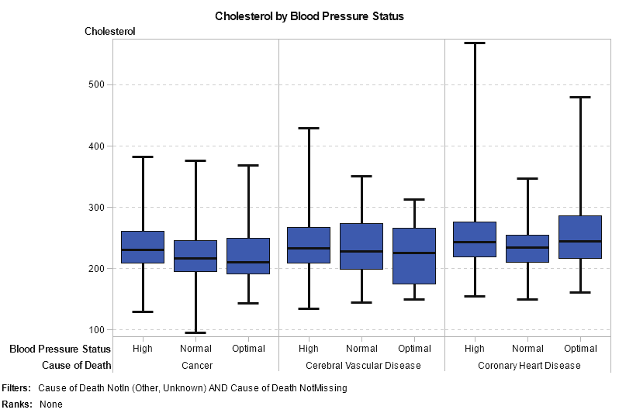

[Application Used: Box and Whisker Plot & Filter]

Visualization illustrates the distribution of the Cholesterol range with respect to Blood Pressure status i.e. High, Normal, Optimal and with respect to Cause of Death i.e. Cancer, Cerebral Vascular Disease and Coronary Heart Disease. It could be observed that the average cholesterol levels for the cause of death – Coronary Heart Disease is much higher as compared to any other causes of death especially for the optimal blood pressure ranges. This could be due to the relation between the cholesterol levels and coronary heart diseases.

1. **Weight Status by Age Coronary Heart Disease detected**

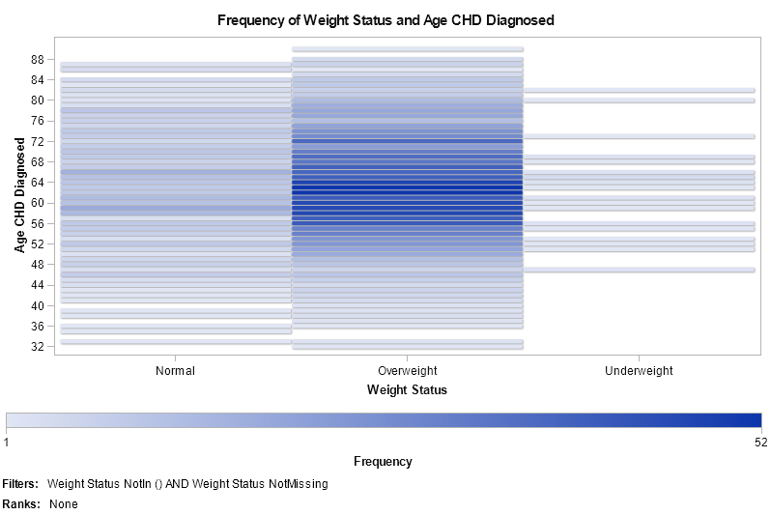

[Application Used: Heat Map & Filters]

Visualization shows distribution of 2 variables i.e. Weight Status and Age at which the Coronary Heart Disease was detected. We can observe looking at the visualization that the frequency of Coronary heart disease in more in number for the patients who are overweight and more for people between age range 58 to 72. This helps us determine the impact of obesity on coronary heart diseases. People with weight status overweight are more prone to coronary heart diseases whereas people with weight status underweight are less prone to heart diseases.

1. **REPORT DESIGNER**
2. **Age Range by Hypertension and Hyperlipidemia**

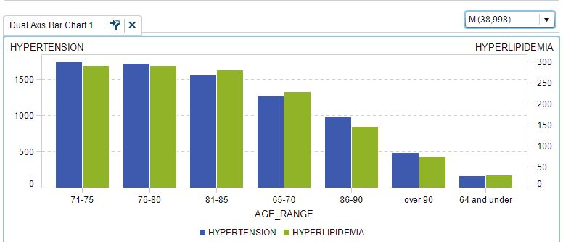

[Application Used: Dual Axis Bar Chart and Drop-Down List]

Report demonstrates the dual axis bar chart for the varying variable values Hypertension and Hyperlipidemia for the all age range. This could be visualized both for Male and Female for different age ranges. We can observe that both Hypertension and Hyperlipidemia increases with the age as both are associated with the cholesterol lipid level in human body. Hyperlipidemia is the presence of too many means too many lipids (or fats), such as cholesterol and triglycerides in the blood.

1. **Diabetes Type 1 and Type 2 Trends for Time Period (2007 – 2012)**

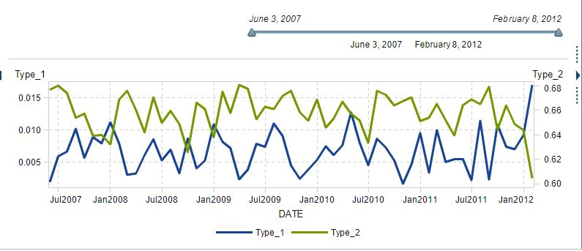

[Application Used: Dual axis time series plot and Button Bar]

Report depicts the trend of 2 types of diabetes i.e. type 1 and type 2 over the period of June 2007 and February 2012 with the help Dual axis series plot. We can observe the trends of both types of diabetes over the period and can analyze that the type 2 diabetes is more prevalent over time as compared to type 1 diabetes. With the help of the button bar we can analyze and compare both the types of diabetes over a specific period.

1. **STORY TELLING**
2. **State Rankings based on Systolic and Diastolic Blood Pressure Range**

According to 2018 data from the AHA, an estimated 103 million U.S. adults have high blood pressure. That’s nearly half of all adults. Blood pressure is the force against the walls of your arteries as your heart pumps blood throughout your body. Blood Pressure are of 2 types –systolic pressure and diastolic pressure:

* Systolic pressure (the top number) is the pressure in arteries as the heart beats. “Normal” systolic pressure is less than 120 millimeters of mercury (mm Hg).
* Diastolic pressure (the bottom number) is the pressure in arteries in between heartbeats. “Normal” diastolic pressure is less than 80 mm Hg.

If the blood pressure is higher than 120/80, then there is a risk for heart disease. We use the defined by the American Heart Association to guide us when diagnosing and treating hypertension. The American Heart Association warns of many possible consequences of high blood pressure, such as: Angina (chest pain), Damage to the heart and coronary arteries and Stroke.

Our analysis shows the ranking of each of the state in accordance to the patients with high ranges of systolic and diastolic blood pressures. Texas, Pennsylvania, Illinois ranking among the top states for large number of patients with high range blood Pressure. Based on the analysis it would be recommendable for the government to implement quality disease Management Programs with an increased concentration for such plans on the states with the highest number of chronic blood pressure patients.

1. **State Rankings by Hypertension and Renal Diseases for Age Group 65 - 70**

Followed by the above analysis we could confirm based on the findings of the current analysis where the states were ranked with respect to Hypertension and Renal Diseases that the States Texas, Pennsylvania and Illinois with large number of blood pressure patients eventually suffer with the chronic conditions related to the high blood pressures. This affirms our point that of implementing high quality and increased number of organizations performing disease management programs for such states.

In some similar programs around the country, dietitians help patients choose healthy food options and fitness coaches help with exercise regimens. As per the citations from National Centre for Biotechnology Information in San Antonio, free home blood pressure cuffs, bought with a grant from the American Heart Association, have armed patients with a tool for self-monitoring. The investment has also saved money, in terms of inpatient and outpatient from August to October 2016, for example, 160 new patients were able to control their blood pressure, resulting in a total savings of more than $2 million in inpatient and emergency room visits, according to University Health System. As part of a national push to embrace this model, the Centers for Disease Control and Prevention and the Centers for Medicare and Medicaid Services co-launched a program called Million Hearts in 2012, aimed at preventing heart attacks and strokes. The team needn't be big to be effective, she adds. Small practices or solo doctors might train a receptionist to be a motivational interviewer or have medical assistants keep in touch with patients between appointments. Often, referral to community resources like walking groups is part of the plan. The program helps physicians around the U.S. share evidence, best practices and educational materials as research discovers new ways to manage hypertension. Encouraging a multidisciplinary team approach is a major goal.

1. **Interaction of Systolic and Diastolic Blood Pressure with Cholesterol**

Visualizations depicted the relation between the increase in systolic and Diastolic blood pressures in the patients with their cholesterol levels. Our visualizations would help the disease management program to monitor patients with such blood pressure conditions and have a close watch on them for their cholesterol levels. In this way the disease management programs would provide precautionary steps to avoid situations that might lead to the increased levels of cholesterol levels in such patients.

As per the findings of National Centre for Biotechnology Information A total of 7735 men, aged 40-59 years at screening, were selected at random from one of the general practices in each of the 24 towns participating in the cross-sectional (screening) phase of the British Regional Heart Study. Blood pressure and levels of blood lipids (serum total cholesterol, high-density-lipoprotein (HDL) cholesterol and triglycerides) and blood glucose were measured.

In 5597 men, heart rate showed a strong positive correlation with cigarette smoking and body-mass index and decreased significantly at higher levels of physical activity and FEV1 (forced expiratory volume in 1). These associations remained significant after adjustment for each other. Age, alcohol intake and social class were not independently associated with heart rate. There was a significant positive association between heart rate and systolic and diastolic blood pressures, levels of blood cholesterol, triglycerides and blood glucose and a significant inverse association between heart rate and HDL-cholesterol levels, even after adjusting for the above confounding factors. After further adjustment for each of the other physiological variables, heart rate remained independently associated with diastolic and systolic blood pressures and levels of triglycerides and blood glucose. The relationship between heart rate and levels of total cholesterol and HDL cholesterol appeared to be secondary to its association with triglyceride levels.

1. **Cholesterol by Blood Pressure and Cause of Death**

Our Visualization depicted the distribution of the cholesterol levels for blood pressure as well as causes of death showing the maximum average distribution for category of coronary heart diseases. This demonstrated the strong relation of the high cholesterol levels and high blood pressure levels would have on the heart. As cited by Centers for Disease Control and Prevention

Heart disease, stroke, and other cardiovascular (blood vessel) diseases are among the leading cause of death and now kill more than 800,000 adults in the US each year. Of these, 150,000 are younger than age 65. These diseases are also two of the leading causes of health disparities in the US. Treatment of these diseases’ accounts for 1 in every 6 US health dollars spent. Two main reasons people have heart disease or stroke are high blood pressure and cholesterol, which are common, deadly, and preventable. Nearly 2 out of 3 adults with high cholesterol and about half of adults with high blood pressure don’t have their condition yet under control. Clearly, other steps are needed to gain control of these health risks.

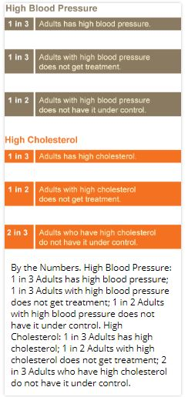

1. **Coronary Heart Diseases by Weight Status and Age.**

Our visualizations depicted the frequency of the Coronary heart diseases for people with weight status – overweight. We also analyzed that the frequency is more in number for the age of people between 58 to 72. As cited by the Centers for Disease Control and Prevention Obesity is common, serious, and costly. In 2009, about 2.4 million more adults were obese than in 2007. This epidemic has affected every part of the United States. In every state, more than 15% of adults are obese, and in nine states, over 30% of adults are obese. The medical care costs of obesity in the United States are staggering. Recent estimates of the annual medical costs are as high as $147 billion. More efforts are needed, and new federal initiatives are helping to change our communities into places that strongly support healthy eating and active living. Obesity is a contributing cause of many other health problems, including heart disease, stroke, diabetes, and some types of cancer. These are some of the leading causes of death in the U.S. Obesity can cause sleep apnea and breathing problems and make activity more difficult. Obesity can also cause problems during pregnancy or make it more difficult for a woman to become pregnant.

**REFERENCES:**

1. <https://www.americashealthrankings.org/explore/annual/measure/Hypertension/state/TX>
2. <https://utswmed.org/medblog/high-blood-pressure-heart-disease/>
3. <https://www.cdc.gov/bloodpressure/measure.htm>
4. <https://www.ncbi.nlm.nih.gov/books/NBK279412/>
5. <https://www.ncbi.nlm.nih.gov/pubmed/7621302>
6. <https://www.cdc.gov/vitalsigns/cardiovasculardisease/index.html>
7. <https://www.cdc.gov/obesity/resources/factsheets.html>